1 Answer:

<html>

<head>

<title>Student Data</title></head>

<style>

th{

padding: 5px 51px;

background-color: #ffbc00;

}

#td1{

padding: 9px 0px;

}

table{

border-collapse: collapse;

}

.com{

background-color: red;

}

#ig{

margin: 0px 14px;

}

caption{

color: #037ffe;

padding: 8px 0px;

font-weight: bold;

}

td{

padding: 0px 14px;

}

</style>

<body>

<table border="2">

<caption style="text-decoration:underline">Student Data</caption>

<tr>

<th>Name</th>

<th>Roll No</th>

<th>Phno</th>

<th>Phno</th>

<th>Id</th>

</tr>

<tr>

<td>Ram Das</td>

<td>2034</td>

<td>9876555</td>

<td>0098765</td>

<td><img src="image.jpg" height="50" width="50" id="ig"></td>

</tr>

<tr>

<td>Rita</td>

<td>7889</td>

<td colspan="2">99000</td>

<td><img src="image.jpg" height="50" width="50" id="ig"></td>

</tr>

<tr>

<td>Mina</td>

<td>123</td>

<td rowspan="2" class="com">99876544</td>

<td>998765</td>

<td><img src="image.jpg" height="50" width="50" id="ig"></td>

</tr>

<tr>

<td>Rahul</td>

<td>23</td>

<td></td>

<td><img src="image.jpg" height="50" width="50" id="ig"></td>

</tr>

<tr>

<td id="td1"></td>

<td id="td1"></td>

<td id="td1" class="com"></td>

<td id="td1"></td>

<td id="td1"></td>

</tr>

</table>

</body>

</html>

Output:

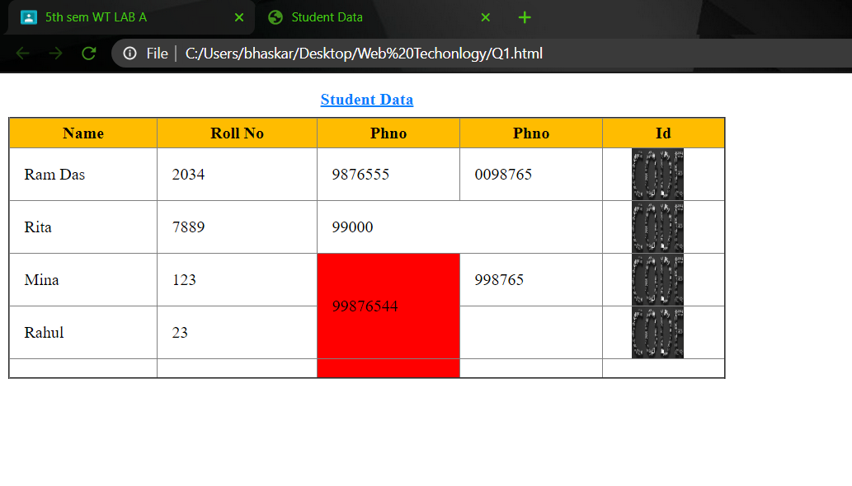

2 Answer:

<html>

<head><title>Biodata</title></head>

<style>

.container{

background-color: white;

margin: 0px 350px;

height: 118%;

border-radius: 6px;

}

body{

background-color: #d3d3d3;

}

#headdiv{

height: 132px;

display: flex;

align-items: center;

justify-content: center;

}

h1{

font-size: 47px;

}

.content1,.content2,.content3{

margin: 0px 31px;

}

h2{

background-color: #bbdde5;

margin: 0px;

border-radius: 5px;

padding: 3px 8px;

}

.innerdiv1,.innerdiv2,.innerdiv3{

margin: 0px 7px;

}

table{

width: 100%;

margin: 15px 0px;

text-align: center;

border-collapse: collapse;

}

p,td{

font-size: 17px;

}

#qualify{

font-size: 22px;

}

hr{

margin: 15px 33px;

}

</style>

<body>

<div class="container">

<div id="headdiv">

<h1>BIO-DATA</h1>

</div>

<hr>

<div class="content1">

<h2>PERSONAL DETAILS:</h2>

<div class="innerdiv1">

<p>Name: Bhaskar Jyoti Deka</p>

<p>Address: Maligaon Officers Colony</p>

<p>Pincode: 781011</p>

<p>Birth Date: 04-08-1998</p>

<p>Age: 22</p>

<p>Contact No: 99678-12345</p>

<p>Nationality: Indian</p>

<p>State: Assam</p>

<p>City: Guwahati</p>

<p>Marital Status: Unmarried</p>

</div>

</div>

<div class="content2">

<h2>SCHOOL/COLLEGE:</h2>

<div class="innerdiv2">

<p>School: South Point School</p>

<p>College: Shankalp Academy</p>

</div>

</div>

<div class="content3">

<h2 id="qualify">QUALIFICATION:</h2>

<div class="innerdiv3">

<table border="2">

<tr>

<th>Standard</th>

<th>Board</th>

<th>Year Of Passing</th>

</tr>

<tr>

<td>Class 10</td>

<td>CBSE</td>

<td>2015</td>

</tr>

<tr>

<td>Class 12</td>

<td>AHSEC</td>

<td>2017</td>

</tr>

</table>

</div>

</div>

</div>

</body>

</html>

Output:

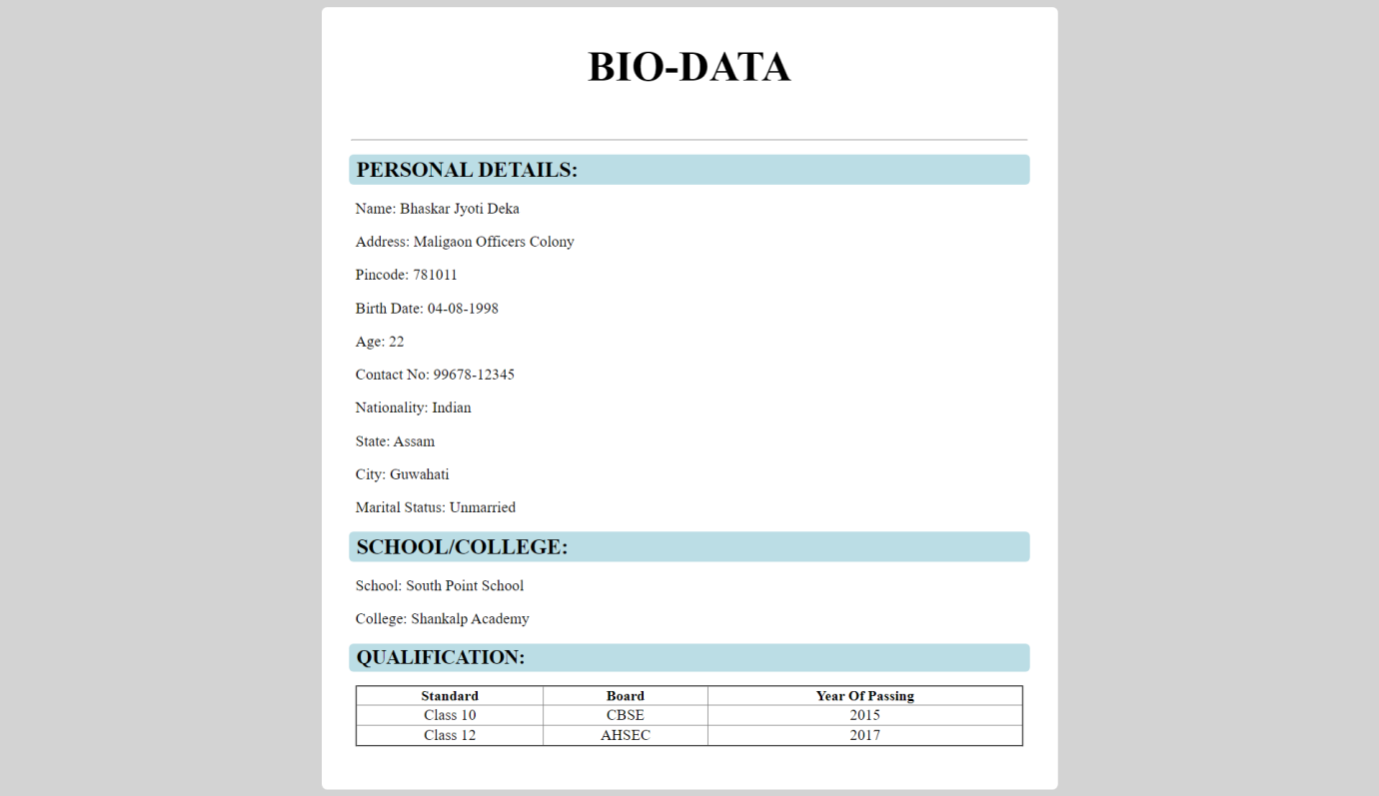

3 Answer:

<html>

<head><title>Subject and its topics</title></head>

<style>

.container{

display: flex;

flex-direction: column;

justify-content: center;

align-items: center;

}

body{

background-color: #6ea5ba;

}

li{

font-size: 18px;

color: white;

}

h1{

font-size: 40px;

color: #e4ff00;

}

</style>

<body>

<div class="container">

<h1>List Of Subjects</h1>

<ol>

<li>C Programming</li>

<ul>

<li>Introduction</li>

<li>Conditonal Statements</li>

<li>Loops in C</li>

<li>Flowchart</li>

</ul>

<li>Data Structure</li>

<ul>

<li>Stack and its operations</li>

<li>Queue and its types</li>

<li>Linked List(Single,Circular and Doubly linked list)</li>

<li>Tree</li>

</ul>

<li>Web Development</li>

<ul>

<li>HTML</li>

<li>CSS</li>

<li>Javascript</li>

<li>PHP</li>

<li>React Native</li>

</ul>

<li>Engineering Mechanics</li>

<ul>

<li>Introduction</li>

<li>Free Body Diagram</li>

<li>Force and Pressure</li>

</ul>

</ol>

</div>

<hr>

</body>

</html>

Output:

